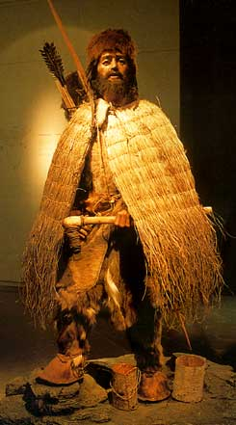
Comparison of Paleolithic / Neolithic People
Dependent on Natural Resources
Paleolithic: Moved with food supply.
Neolithic: Water and good soil for crops.
Government
Paleolithic: Families (male ruled) evolutionary, from family to village to city.
Neolithic: Chief with council.
Economy
Neolithic: Barter system.
Religion
Polytheistic - believed in life after death.
Social
Men hunted; women gathered / farmed.
Technology
Paleolithic: Stone tools
Neolithic: Farming, baking and firing pottery, specialized tools, bronze tools and weapons

Fall / Evolution
Paleolithic: Ice Age forced them to move and change.
Neolithic: Moved and evolved.

Neolithic Era
Origins of Government
Villages became larger, growing into cities. Government and religion were organized. The development of specialized occupations and advanced technology occurred. The use of written symbols to keep records began.
Class System
There were a lot of people with internal struggle; some people felt they were better than others and could bring order and protection from raids.
Role of Government:
Organized to plan large projects (control water for irrigation, etc.)
Needed to maintain laws and judge lawbreakers.
Oversee large projects.
Collect taxes.
Rulers were seen as either gods or having been chosen by the gods. Laws were seen as coming from the gods. People were ruled harshly. It was seen as the only way (by the rulers) to get the people to submit - by being afraid). A state of war always existed: either between one people and another, or between the people and a ruler.
Origin of Formal Religion
Formal religion explains creation and life after death. Religions also formed for social reasons, provided comfort and solace, and brought harmony with the environment.
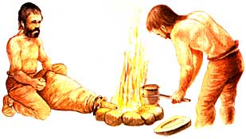
Bronze Age People Used Bronze to Make Swords and Tools.
Development of Specialized Occupations
Artisans, merchants, and government. Officials led to new skills and knowledge. New ideas came from people trading with other people from other places.
Writing
Writing developed to keep records as government, religion, and trade got more complex. Almost all ancient civilizations came up with some form of writing.

